
Closing Instructions
The instructions provided herein are to be used with UN marked plastic tight head drums (UN 1H1) and jerricans (UN 3H1) that are in compliance with the US Department of Transportation’s hazardous material regulations. This falls under the Title 49 Code of Federal Regulations, in accordance with subsection 178.2 (c).
It is the obligation of the filler to use and follow these closure instructions to ensure that the product meets required UN markings and performance. Only when assembled in the manner below are these packages certified to meet the UN marking provided.
Purpose:
When following these instructions, the purpose of these closure instructions is to ensure that the UN container, with required fittings, are properly applied to the UN marked plastic drum or jerrican.
Drums:
UN 1H1 tight head 15-gallon plastic drums
2-inch NPS x ¾-inch NPS
2-inch NPS x 2-inch buttress

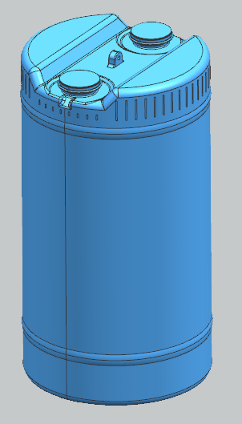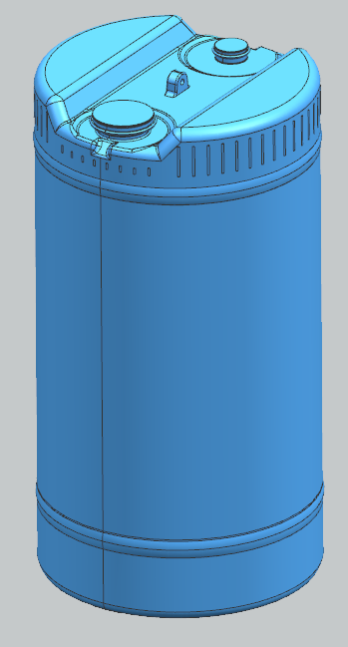
Procedure:
- Inspect all threads on the plugs (NPS = fine thread, buttress = coarse thread). They must be clean, dry, and free of defects.
- Inspect the gaskets on the plugs. They must be clean, dry, and free of tears or other defects.
- Inspect the flanges (the threaded parts of the drum). The threads should be clean, dry, fully formed, and free of defects.
- Turn the plug clockwise by hand to engage the threads and continue to “finger tight” making sure the threads are engaging and not cross threading. Attach appropriate adjustable or preset drum plug wrench and continue tightening to the following torque settings:
  - 2-inch NPS fine thread 20-25 ft-lbs.
  - 2-inch American buttress coarse thread 20 ft-lbs.
  - ¾-inch NPS fine thread 10 ft-lbs.
- The plugs are tightened when the torque wrench makes an audible “click.” Do not tighten any further as the gaskets may be twisted or the plastic threads may be damaged.
- Visually check the installation to verify the plugs are even in their flange and not lose or cross threaded.

UN 1H1 tight head 30-gallon plastic drums
2-inch NPS x 2-inch buttress

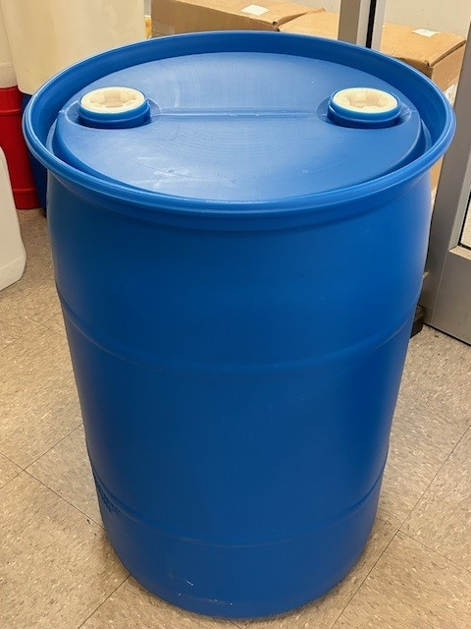
Procedure:
- Inspect all threads on the plugs (NPS = fine thread, buttress = coarse thread). They must be clean, dry, and free of defects.
- Inspect the gaskets on the plugs. They must be clean, dry, and free of tears or other defects.
- Inspect the flanges (the threaded parts of the drum). The threads should be clean, dry, fully formed, and free of defects.
- Turn the plug clockwise by hand to engage the threads and continue to “finger tight” making sure the threads are engaging and not cross threading. Attach appropriate adjustable or preset drum plug wrench and continue tightening to the following torque settings:
  - 2-inch NPS fine thread 20-25 ft-lbs.
  - 2-inch American buttress coarse thread 20 ft-lbs.

- The plugs are tightened when the torque wrench makes an audible “click.” Do not tighten any further as the gaskets may be twisted or the plastic threads may be damaged.
- Visually check the installation to verify the plugs are even in their flange and not lose or cross threaded.

UN 1H1 3.5 – 7.0-gallon tight head drums with crimp-on spout fittings
UN 3H1 3.5 – 7.0- gallon square and rectangular jerricans with spout fittings
Procedure:
- Inspect the top of the container and flange area to ensure the sealing surface is smooth, clean, dry, and free of defects and debris.
- Inspect the spout fitting to ensure it is clean, dry, and free of debris and defects.
- Start the installation of the Rieke® spout fitting by hand, snapping the spout over the flange of the drum. Make sure the fitting is installed straight and alignment is square.
- Use the only crimp on wrench supplied by the spout manufacturer. See Pictures below.
  - Place the crimper securely and evenly (level) on the spout with the handles up as shown below.
  - In a firm even motion bring the handles down to crimp the spout to the drum.
- Inspect the crimp to make sure the outer diameter of the spout has securely crimped around the flange of the container. It should look clean, flush, level and solid. There should be no gaps. The spout should not be able to be moved or rotated. If it can it is not crimped properly and should be rejected.
Rieke Spout and Crimper
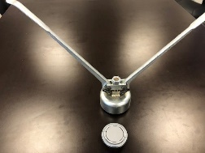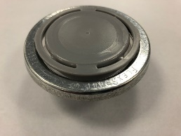

TriSure Spout and Crimper
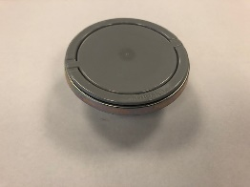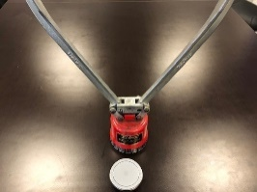

UN 3H1 square and rectangular 10-liter to 7-gallon tight head jerricans with Tamper Evident 61, 70 mm closures with 21, 22 mm vent caps and with no rear vent cap.
3.5-gallon Square 3H1
5-gallon Rectangular 3H1

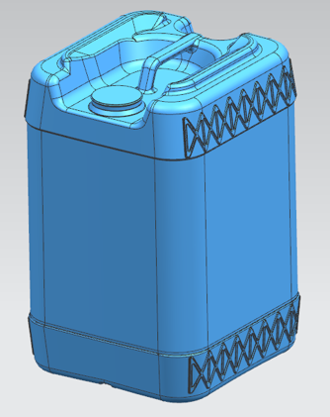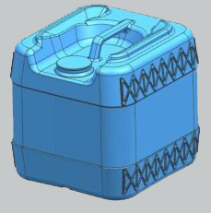
Procedure:
Note the closing instructions are the same for cross-hatching jerricans as shown above and those without cross-hatching.
- Inspect the top of drum opening to ensure the sealing surface is smooth, clean, and free of debris or defects.
- Inspect the 61, 70 mm, 21mm and 22 mm screw cap fittings to ensure the gaskets are installed properly and are not lose or torn.
- Inspect the 61, 70 mm, 21mm and 22 mm screw cap fittings to ensure the fittings are clean and free of debris.
- Start installation of the Tri-Sure® (or Rieke) 6TPI 70 mm or 61mm screw cap fitting by hand, rotating the fitting in a clockwise direction. Ensure the fitting is being installed straight and does not cross-thread the drum threads. Continue to tighten as far as possible by hand.
- Use a screw cap torque wrench to torque the fitting to 15-20 ft-lbs. The fitting is tight when an audible “click” or release is evident.
- Rotate the 22 mm vent cap clockwise to “finger tight” Use a vent cap torque wrench to tighten to 2.5 ft-lbs. (30 in-lbs.) Re-torque to 30 in-lbs. after loosening.
- Visually check installation to verify the plugs are even in the flange and not loosened or cross threaded.

Equipment-Available from drum supply houses, automotive supply, DIY centers and “Big-Box” Stores

Preset Torque Wrenches
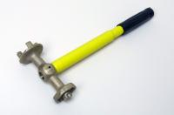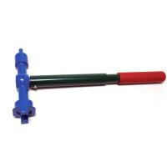
TriSure 15 & 9 ft-lbs.
Rieke 15 & 9 ft-lbs.
Adjustable and Indicating Torque Wrenches
Adjustable w 70 mm cap adapter
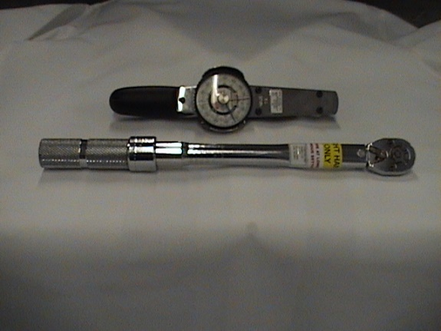
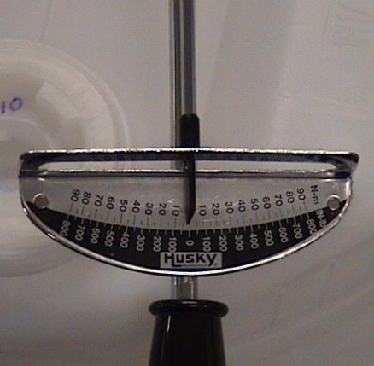
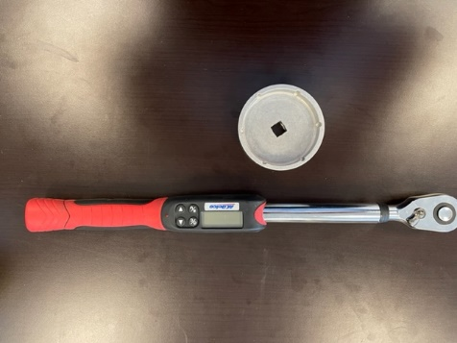
Adjustable w 21 or 22 mm cap adapter

